Delhivery LastMile –Magento Integration
Usage Document

Purpose: 3
License: 3
Installation: 4
Configuration: 8
Pin code Manager: 10
AWB Manager: 12
Add Tracking Number: 14
Pin Code Validation: 15
Submit Manifest: 16
Print Shipping Label: 18
Un-Installation: 19
FAQ: 20

Purpose:

The purpose of this plug-in is to integrate Delhivery LastMile processes with ecommerce stores running on Magento. It provides following feature
- Download and Store client specific AWB series from Delhivery system.
- Download and Store list of serviceable Pin Code from Delhivery system.
- Allocate AWB to Order automatically from stored list while shipping order and Delhivery selected as Carrier
- Pin code Check while shipping order.
- Facility to submit manifest for the allocated AWB.
- Facility to print shipping label for the selected AWB.

License:

This plug-in is being release as part of Commons Creative License.

Installation:

This plug-in will be installed as regular Magento Plug-in.

PRe-Installation Steps:

Downloaded “Delhivery_Lastmile-0.2.0.tgz” file from the link provided by Delhivery.

Installation Steps:

- Go To: System > Magento Connect Manager
- Login as “admin” again.
- Click Choose File Button, Browse the (Delhivery_Lastmile-0.2.0.tgz) File and Click Upload.
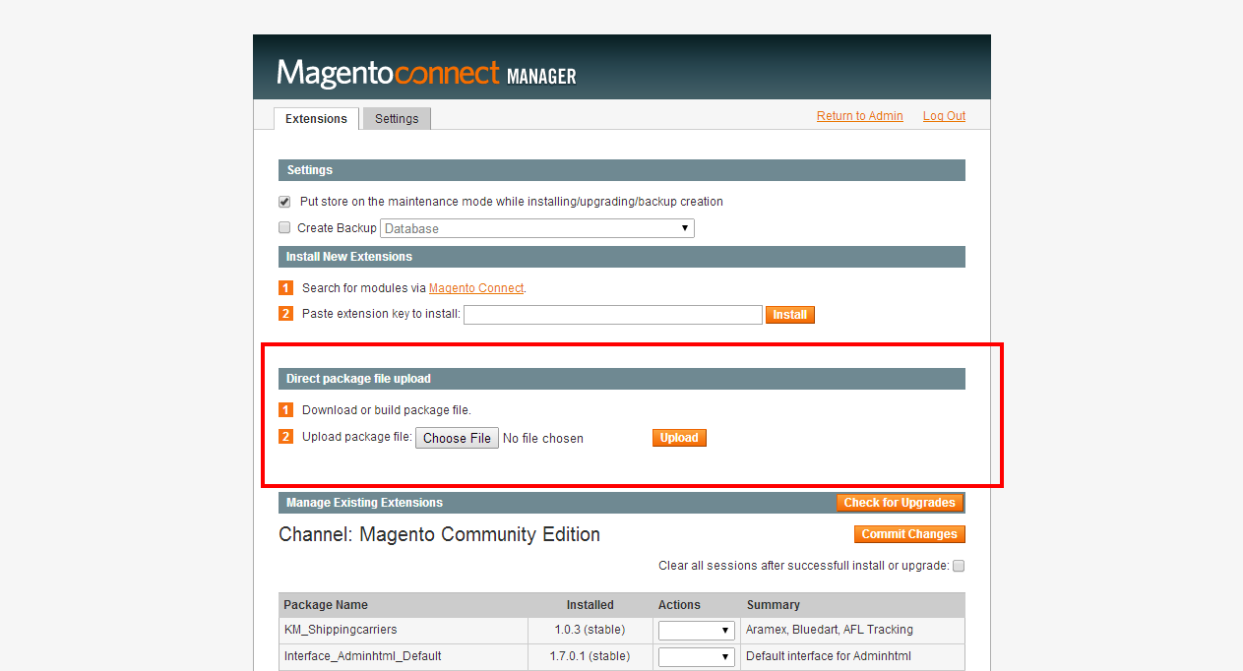

Step 4: Package Installation will start.
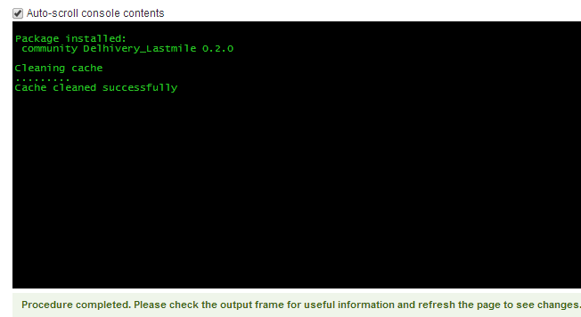

Post installation changes

- New Option (Delhivery ) in Header Menu
Note: Clear your magento cache and try logout/login if you don’t see these option in admin
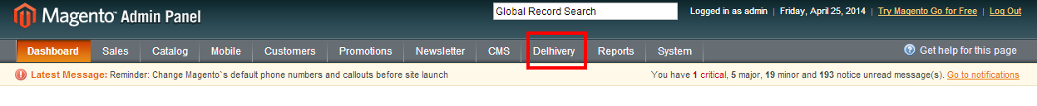
- Folder and File Structure
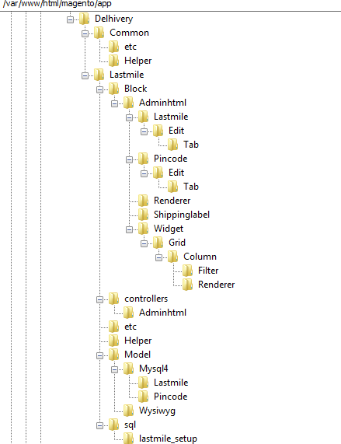
- Database Changes
- Created two new tables
  - delhivery_lm_awb
  - delhivery_lm_pincode

- Insert one record in <core_resource> table , as show below:
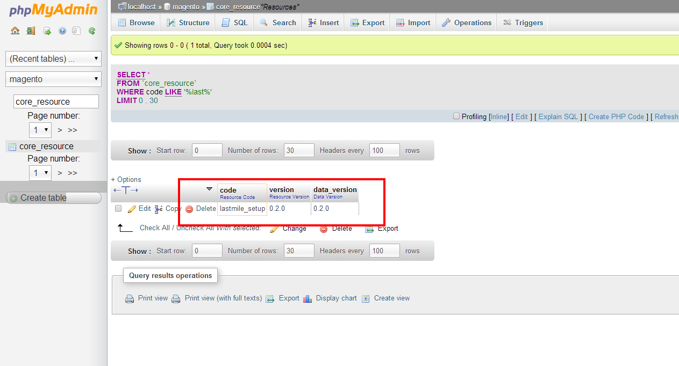

Configuration:

After installation configure settings to run this plug-in. Reach out to <lm-tech@delhivery.com>, for Client Id and License Key.
- Go To: System > Configuration > Shipping Methods

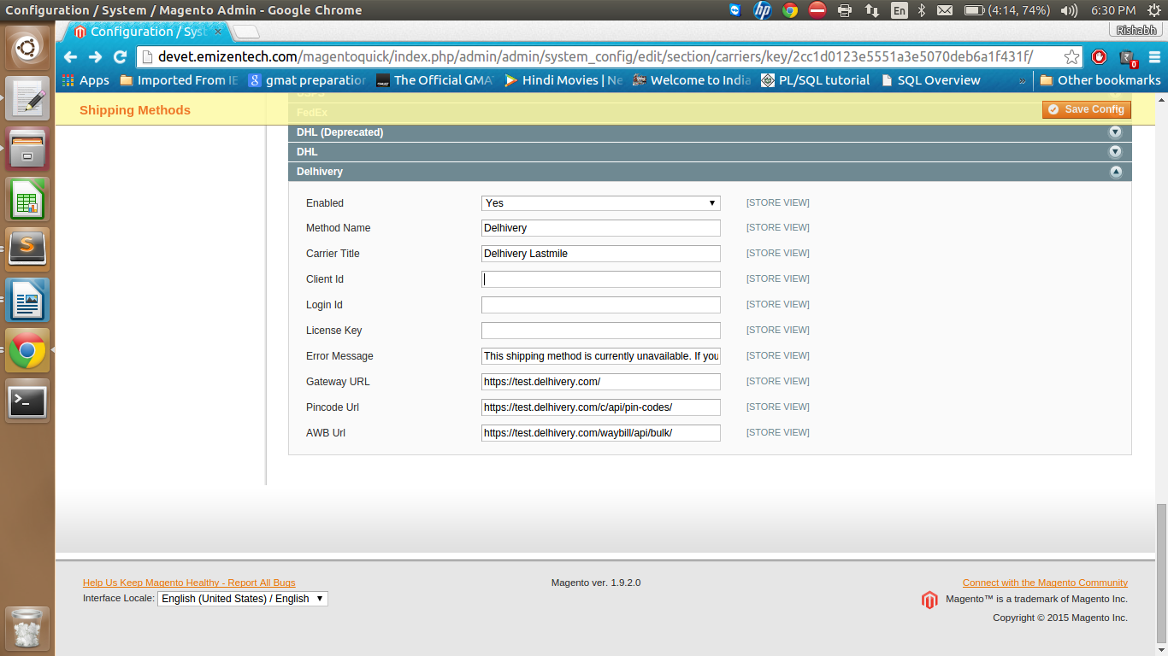

Option | Purpose
Enabled | No → Delhivery will not appear as carrier in shipping options on store view [DEFAULT].  Yes → Delhivery will appear as carrier in shipping options on store view
Method Name | Always Delhivery
Carrier Title | Always Delhivery
Client ID | Name of the Store, specific to client.
Login Id | Future Use
License Key | Token provided by Delhivery, specific to client
Enter Message | This message appears when plug-in is disabled.
GateWay URL | Delhivery Server URL, change to production URL when ready to go live.
Pin Code URL | URL for fetching Pin Code, changes to production URL when ready to go live.
AWB URL | URL for fetching AWB, changes to production URL when ready to go live.

Pin code Manager:

This option shows list of all serviceable Pin Code by Delhivery
- Press [Download Pincode] button to refresh the list. [Note: It will take considerable amount of time depending upon bandwidth available. If you see blank page kindly refresh and click refresh and go to Manage Pin Code option again.]
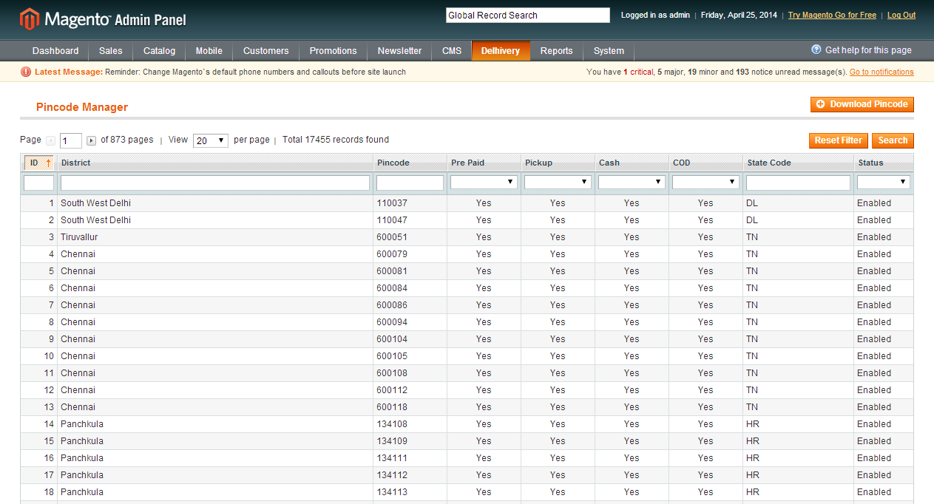
- Not Serviceable Pin codes
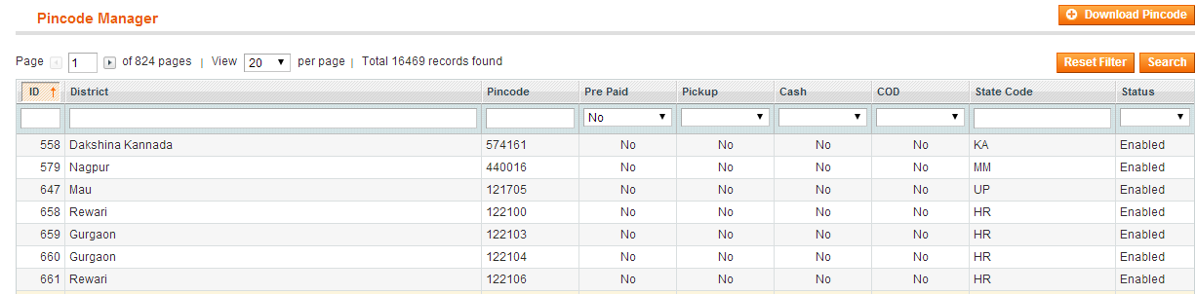

AWB Manager:
- This option shows list of all AWBs downloaded from Delhivery.
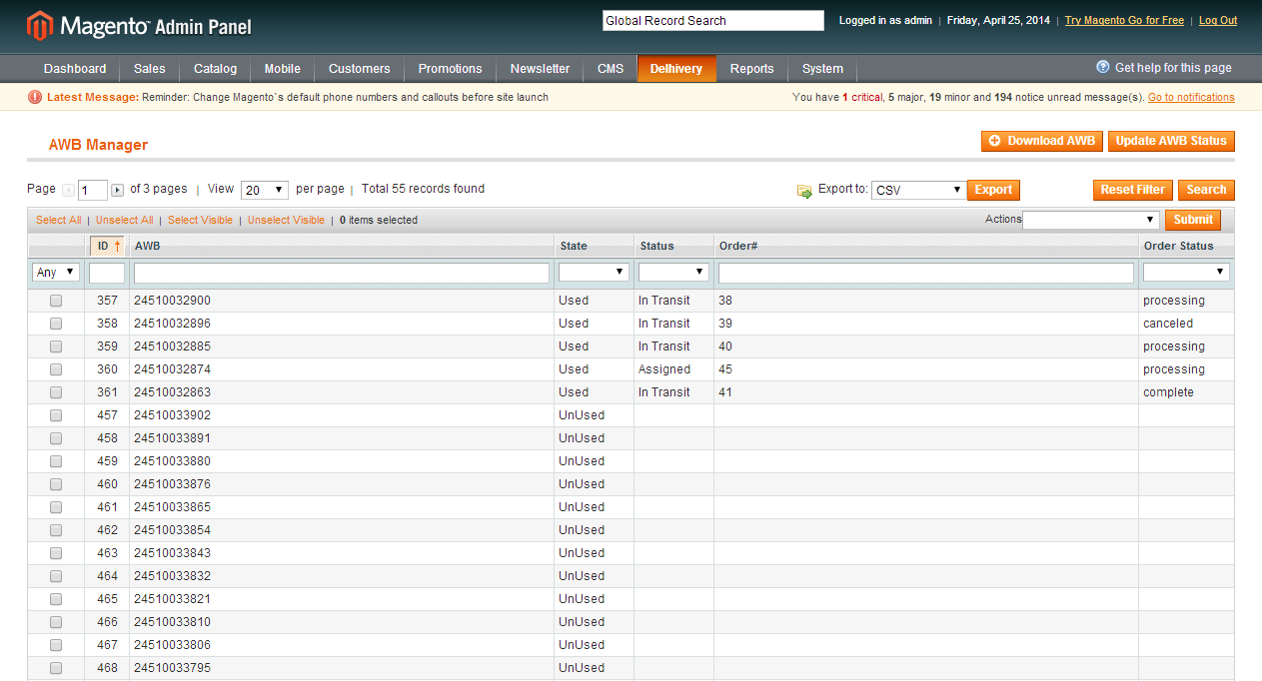
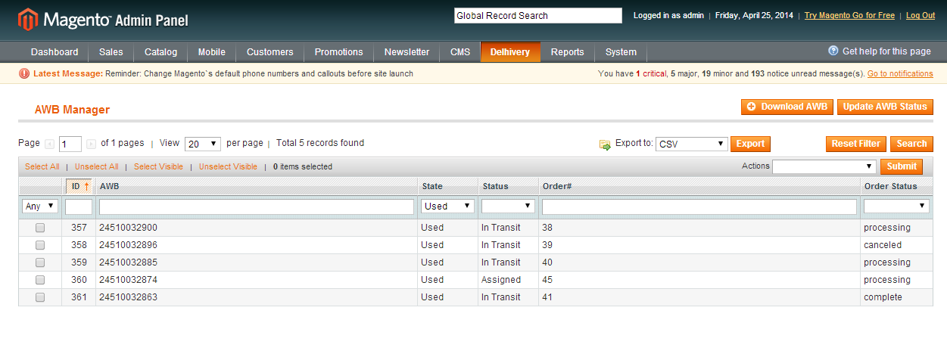

Option | Purpose
AWB | Downloaded AWB series(50) from Delhivery server, AWB series is specific to client and determines by the token provided to client by Delhivery.
State | Used → Allocated to Order  Unused →Not Allocated to Order
Statue | Current Tracking Status of AWB
Order# | Assigned Order#
Order Status | Current Status of Order

- Click [Download AWB] button for download new AWB series.
- Click [Update AWB Status] button to update current tracking status.

Add Tracking Number:
- Click [add Tracking number] button for adding tracking number in Order.
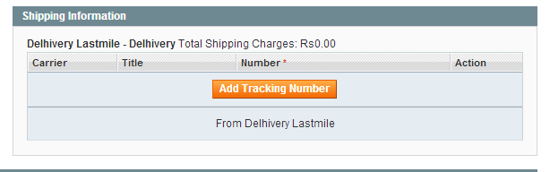
- Click [Delhivery Last Mile] from the option, AWB no will be added automatically.
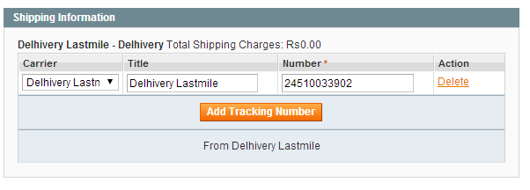

Pin Code Validation:

- Will not allocate AWB if Pin Code not serviceable.
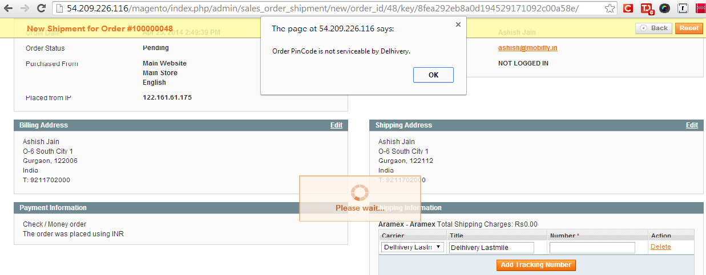
Submit Manifest:
This option allows to Submit Manifest for selected AWB(s). Once manifest submitted successfully Delhivery systems will be notified pickup is ready for the given AWB.
- AWB state will be ‘Used’ and status will be ‘Assigned’ once allocated to order.

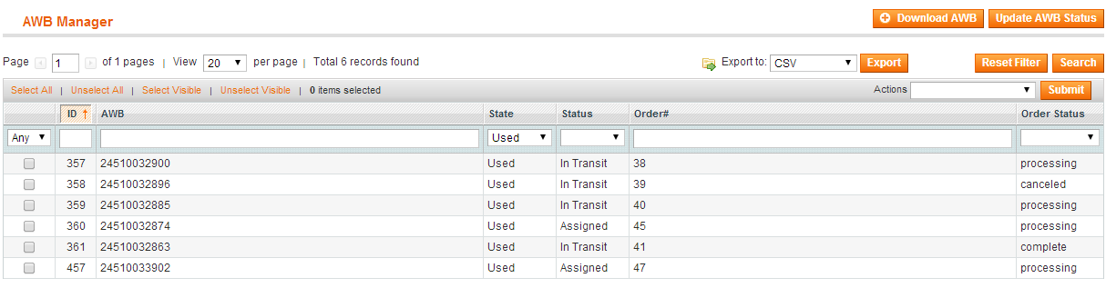

AWB status will be In Transit once manifest submitted successfully.

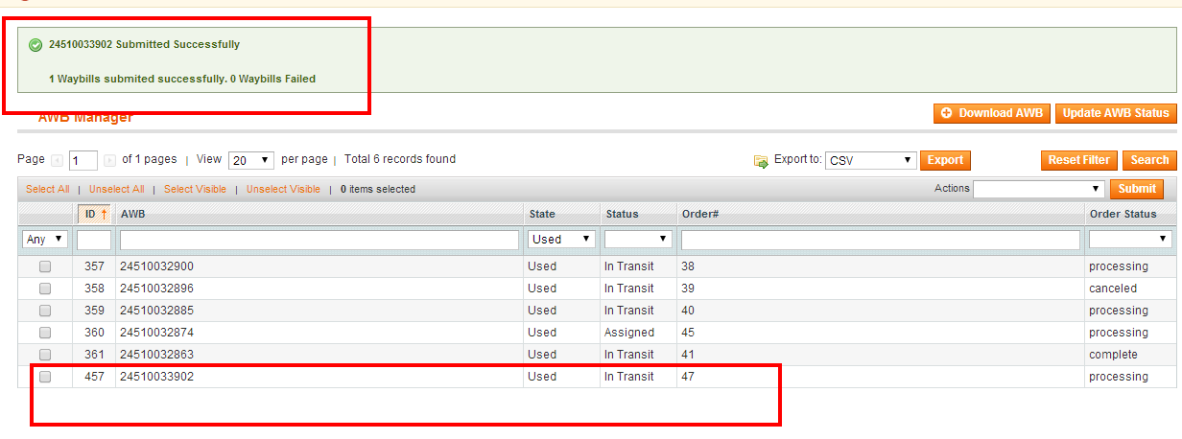

Will not submit manifest for same AWB again.

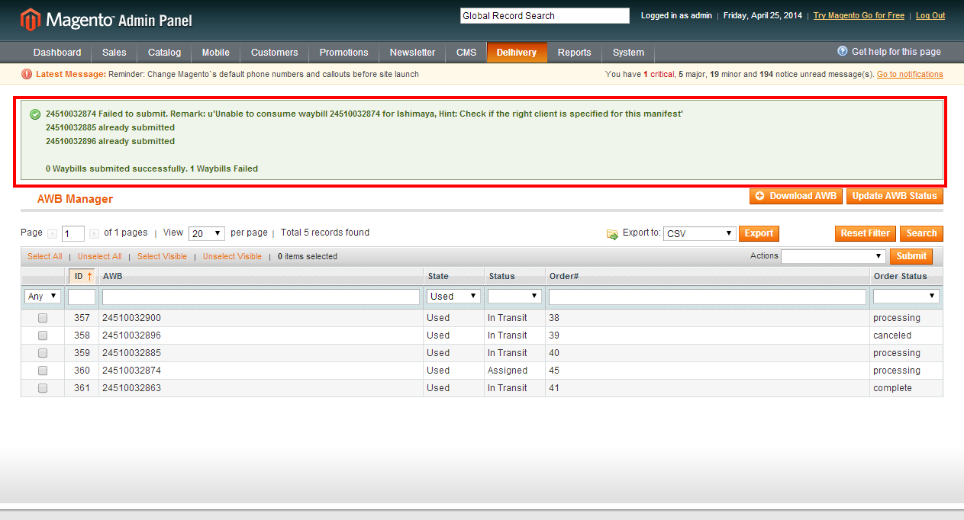

Note:
- Shipping change done in order after manifest submission will not be notified to Delhivery.
- Order status change done in order after manifest submission will not be notified to Delhivery.

Print Shipping Label:
This option allows downloading of shipment label PDF for selected AWB(s). Below is the format of shipping label, each page will have 4 shipping labels.
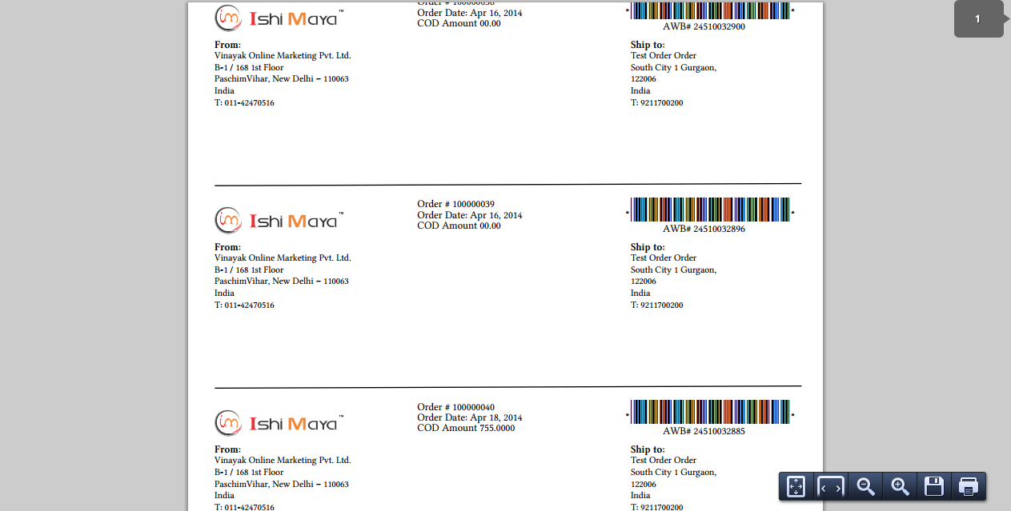

Un-Installation:
- Delete following file → app/etc/modules/Delhivery_Lastmile.xml
- Delete following folder → app/code/community/delhivery
- Delete following file → app/design/adminhtml/default/default/template/delhiverlastmile
- Delete FROM `core_resource` WHERE code = 'lastmile_setup'
Log Files are available at:
../magento/var/log/system.log

FAQ:
- What will be the status of AWB once allocated?
- Status of AWB will be “Assigned” once its allocated to any order
- What will be the status of AWB once manifest submitted?
- Status of AWB at this stage will be “In Transit”
- What if Pin Code / Address changed after allocating AWB no?
A. In such case System will not notify Delhivery for the changes. Should be handled by vendor outside the system.
- What if order cancelled before manifest submission?
- In that case associated AWB will be marked as unused and that can be used for new orders
- What if order cancelled after manifest submission?
- AWB cannot be used for any other order after manifest submission, so it will stay as used
- Can I add Tracking Number Manually?
- No, Tracking number will be assigned automatically whenever Delhivery is selected from the careers list
- Can I delete Shipment Tracking Number?
- Yes tracking number can be deleted from a shipment. If it’s a tracking number from Delhivery, corresponding AWB number will be marked as unused and will be ready to be used for new order
- Can I submit manifest multiple times?
- No, Manifest to Delhivery can be submitted only once for each AWB number. It status can keep updating after successful submission of manifest.
- Can I print shipping label without manifest submission?
- Shipping Label can be printed once an AWB is assigned to an order. Manifest submission is not required for that.

